Sales Performance Dashboard
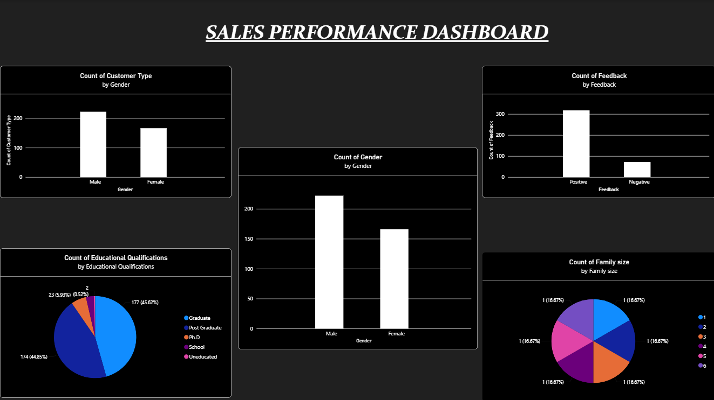
trends
1. Feedback Trend
- Positive feedback significantly outnumbers negative feedback.
- Positive responses account for roughly 75% of all feedback (~280 out of ~370).
- Negative feedback remains a small minority, at around 90 counts.
- Overall, this indicates strong customer satisfaction.
2. Educational Qualification Trend
- The customer base is heavily concentrated in higher education levels.
- Graduates (45.6%) and Post Graduates (44.9%) together make up nearly 90% of all customers.
- PhD holders form a small segment (5.9%).
- School-level and Uneducated categories are negligible (under 1%).
3. Gender Distribution Trend
- The overall gender split is fairly balanced, with a slight male majority.
- Male customers (~190) slightly exceed Female customers (~170).
- No extreme skew is observed at the aggregate level.
4. Customer Type by Gender Trend
- When broken down by customer type, the gap between genders widens further.
- Male customers (~190) clearly outnumber Female customers (~110) in this view.
- This inconsistency with the overall gender chart suggests possible data gaps or filtering differences worth investigating.
5. Family Size Trend
- Each family size category (1–6) shows an identical count of 1 (16.67%).
- This perfectly even distribution is unusual for real customer data.
- It likely reflects a dimension/lookup table rather than actual transaction-level counts and should be verified in the data model.

